Hexameter

📏 What is Hexameter
# Source: Chatgpt (GPT-4-turbo) at [8/2/2025]
Hexameter is a poetic meter composed of six metrical feet per line. It is historically significant in classical epic poetry, especially in Greek and Latin literature. Though rare in English, it has been adapted in certain narrative and formal poetic traditions.

🧱 Structure
# Source: Chatgpt (GPT-4-turbo) at [8/2/2025]
- Each line has 6 feet
- Total syllables range from 12 to 18, depending on the foot type
- Classical hexameter often uses dactyls and spondees:
  - Dactyl: DUM-da-da
  - Spondee: DUM-DUM
- English adaptations may use:
  - Iambic hexameter (also called Alexandrine)
  - Anapestic hexameter or dactylic hexameter (less common)

📝 Example

Dactylic Hexameter (Classical Latin):
# Source: Chatgpt (GPT-4-turbo) at [8/2/2025]
Arma virumque cano, Troiae qui primus ab oris
— Virgil, Aeneid (I sing of arms and the man...)

Iambic Hexameter (Alexandrine):
# Source: Chatgpt (GPT-4-turbo) at [8/2/2025]
A needless Alexandrine ends the song
That, like a wounded snake, drags its slow length along.
— Alexander Pope

🧬 Variants
# Source: Chatgpt (GPT-4-turbo) at [8/2/2025]
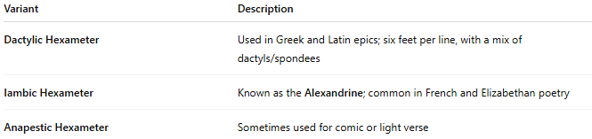
Variant | Description
Dactylic Hexameter | Used in Greek and Latin epics; six feet per line, with a mix of dactyls/spondees
Iambic Hexameter | Known as the Alexandrine; common in French and Elizabethan poetry
Anapestic Hexameter | Sometimes used for comic or light verse

🎭 Effect in Poetry
# Source: Chatgpt (GPT-4-turbo) at [8/2/2025]
- Conveys a grand, formal, or epic tone
- Creates a sense of progression or march-like rhythm
- Suitable for heroic storytelling and mythological themes
- In English, Alexandrine lines are often used to conclude stanzas or expand upon themes

📚 Where It's Found
# Source: Chatgpt (GPT-4-turbo) at [8/2/2025]
Hexameter appears in:
- Classical epic poetry (Homer’s Iliad, Virgil’s Aeneid)
- French classical poetry (Alexandrine as the dominant form)
- Elizabethan and Neo-classical English poetry
- Narrative verse or long reflective poems
- Occasionally in ballads or metrical experiments

